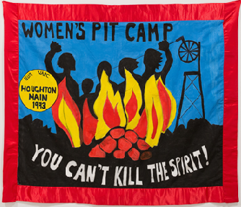
AGREEMENT
For financial contributions towards the cost of the design work &/or printing of the Sheffield WAPC Pit Closures book, ‘You can’t kill the spirit’, 2018.

Background:
The history of the 1984/85 miner’s strike is well recorded. However, the story of the Women against Pit Closures (WAPC) Pit Camps set up in January 1993, is not. The University of Sheffield’s project ‘Stories of Activism in Sheffield, 1960-present’ is supporting members of Sheffield Women against Pit Closures, to tell the story of the pit camp they and local women set up and organised at Houghton Main Colliery in South Yorkshire.

WAPC intend to publish the book in 2018, but have no funding to do so. Contributions towards the cost of designing the book should help attract funding for the publishing of the book once there is completed design to show potential funding bodies, and/or to crowd fund the printing of the book. The aim is for the book to be primarily an image based book, of around 100 pages.

Although we will make every effort to ensure we can repay any contributions if required, we cannot guarantee we will be in a position to do so. Consequently, we are not able to accept any financial contributions where the money must be repaid.

Name of contributor: (please state if you wish your contribution to be anonymous)

Address/contact details:

AMOUNT CONTRIBUTED:

Please state whether you would like your contribution repaid if possible and/or whether you would prefer the contribution to help reduce the cost of the book:

Date:

Sheffield History of Activism/Sheffield WAPC Pit Camp Story Project
Contact/further information: swapcpitcamp1993@gmail.com

