Help us tell the story of the
WOMEN AGAINST PIT CLOSURES (WAPC) PIT CAMPS
Seven pit camps were set up in 1993 in response to the announcement by the Government in October 1992, to close 31 deep mines. This followed the closure of 125 mines since the end of the Miner’s Strike in 1985.
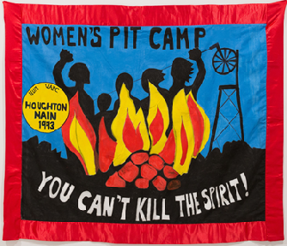
Can you help us tell the story of the Houghton Main Women’s Pit Camp?
We are looking for loans/contributions to cover the design work on a book ‘You can’t kill the spirit’, which we intend to publish later this year.

The book will focus on Houghton Main Pit Camp, which was supported by Sheffield WAPC and local women. The book will include information on the other six pit camps set up at the same time. The history of the 1984/85 miner’s strike is well recorded.
However, the story of the Women against Pit Closures (WAPC) Pit Camps set up in January 1993, is not. The setting up of the pit camps at the most threatened pits followed Heseltine’s announcement of 31 pit closures in October 1992.

The University of Sheffield’s project ‘Stories of Activism in Sheffield, 1960-present’ is supporting members of Sheffield Women against Pit Closures, to tell the story of the pit camp they and local women set up and organised at Houghton Main.

If you would like to help us produce our book, ‘You can’t kill the spirit’ by making a contribution to the cost of the design work please let us know. We think we will be in a better position to attract funding for the publishing of the book once we have a completed design to show potential funding bodies, and/or to crowd fund the printing of the book. The aim is for the book to be primarily an image based book, of around 100 pages.

Contact/further information:
swapcpitcamp1993@gmail.com
Or any of the following contacts:
Sheffield Women against Pit Closures / Houghton Main Pit Camp
Flis Callow (fcallow@gmail.com), Caroline Poland (poland.cf@gmail.com), &/or
Debbie Matthews (djmatthews@hotmail.co.uk)
And/or: Gary (Sheffield History of Activism Project): g.rivett@sheffield.ac.uk

